CPE301 – SPRING 2020

MIDTERM 2

Student Name: Mateo Markovic

Student #: 2001338139

Student Email: Markom1@unlv.nevada.edu

Primary Github address: <https://github.com/mateom99/submission_da>

Directory: Midterms/Midterm2

1. **COMPONENTS LIST AND CONNECTION BLOCK DIAGRAM w/ PINS**

* Atmega328PB-Xmini w/ Atmel Studio 7.0
* Atmega328PB Debugger for Serial to USB output
* Arduino Multi-Function Shield (Potentiometer at PC0)
* DC Motor w/ TB6612FNG Driver IC and Encoder (PD2-PD5)

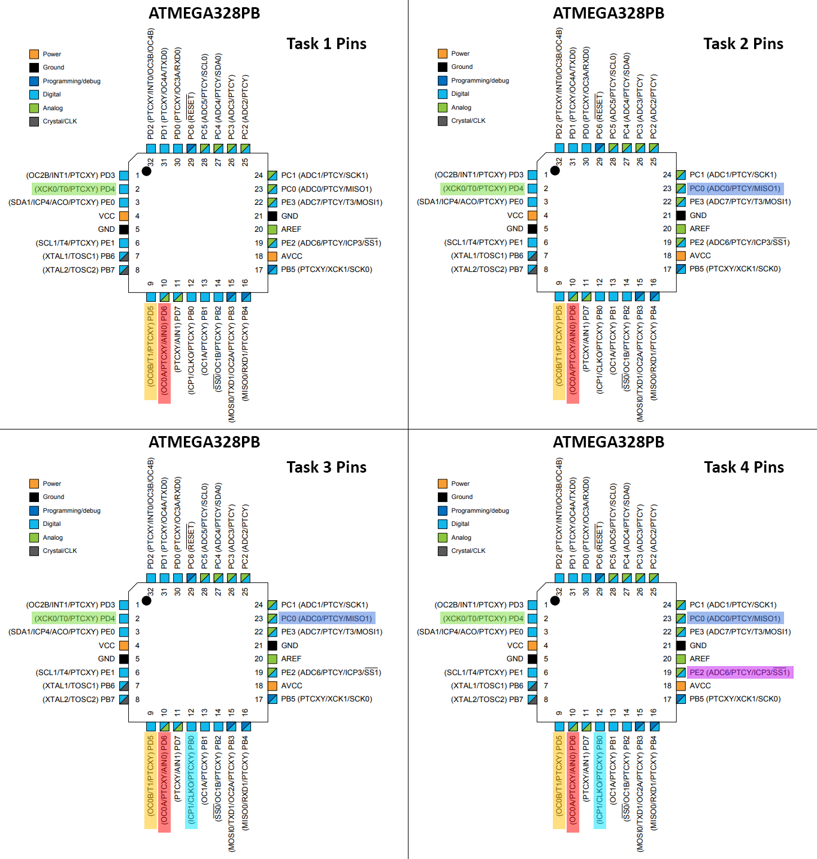

1. **INITIAL/MODIFIED/DEVELOPED CODE OF TASK 1**

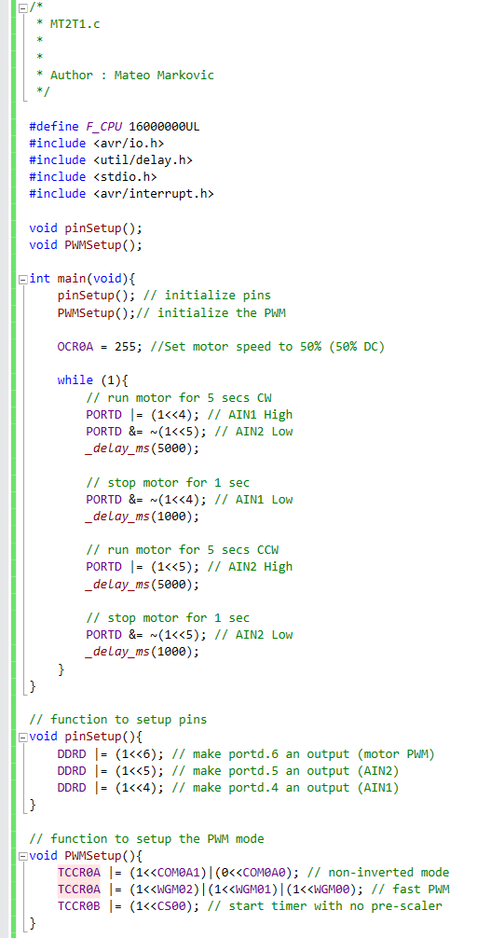

1. **DEVELOPED MODIFIED CODE OF TASK 2 from TASK 1**

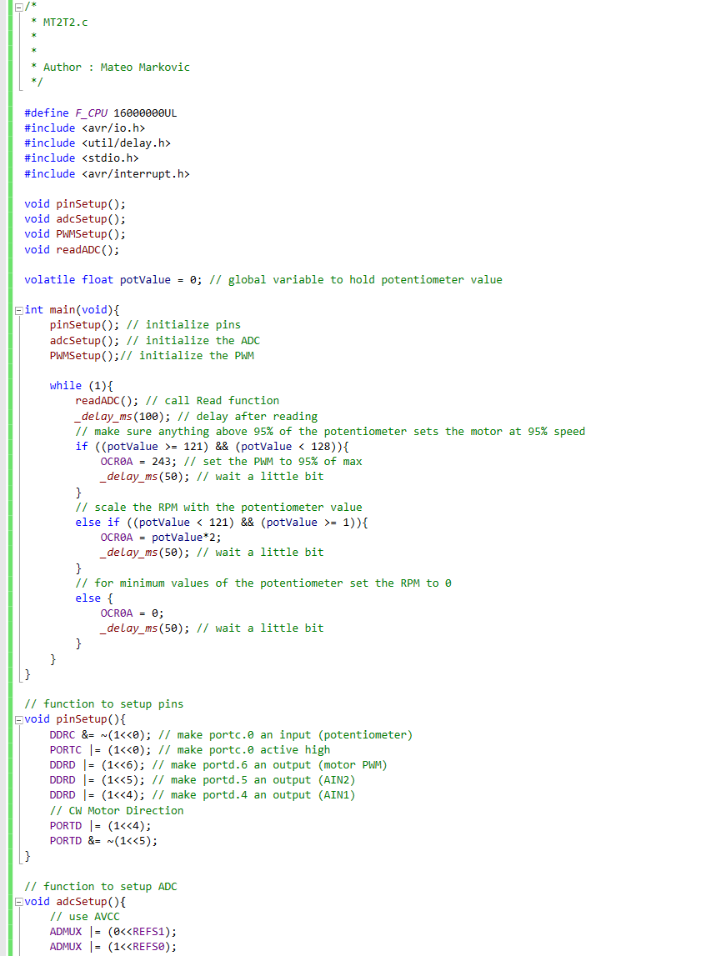

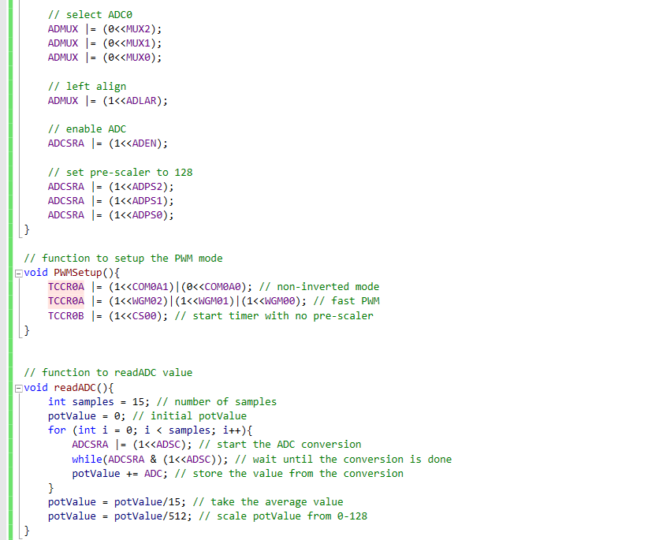

1. **DEVELOPED MODIFIED CODE OF TASK 3 from TASK 2**

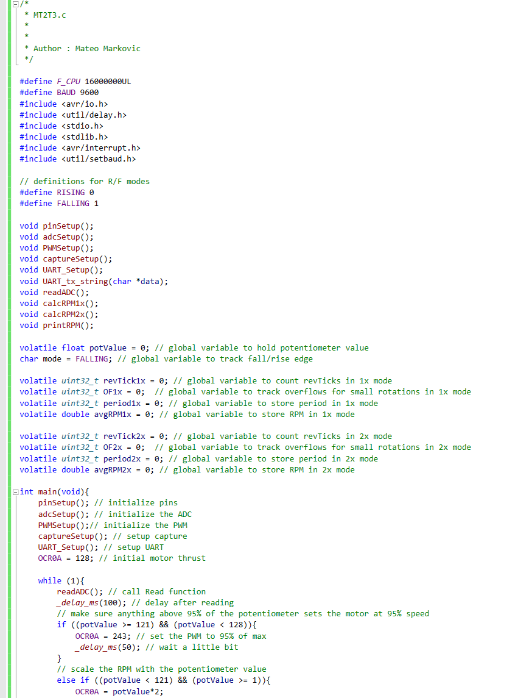

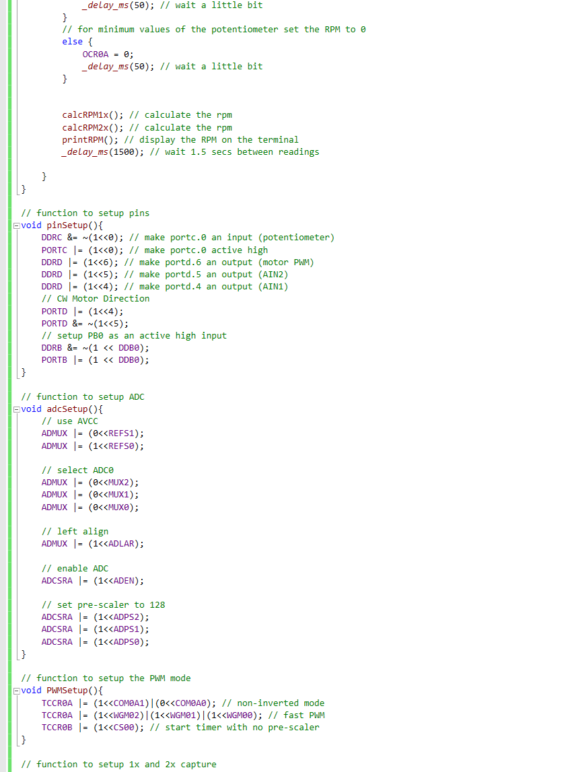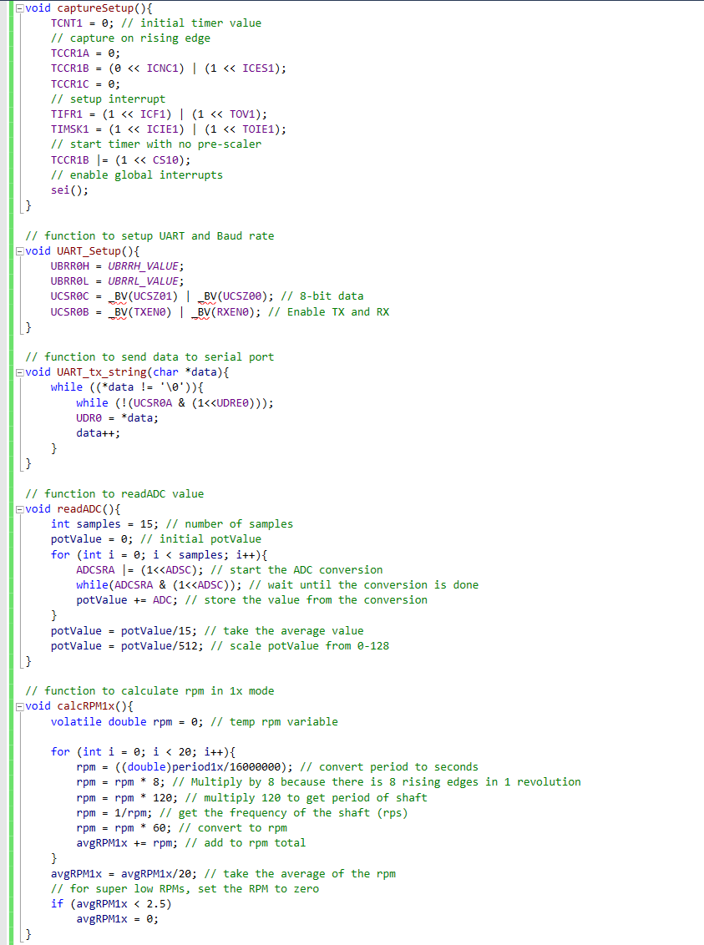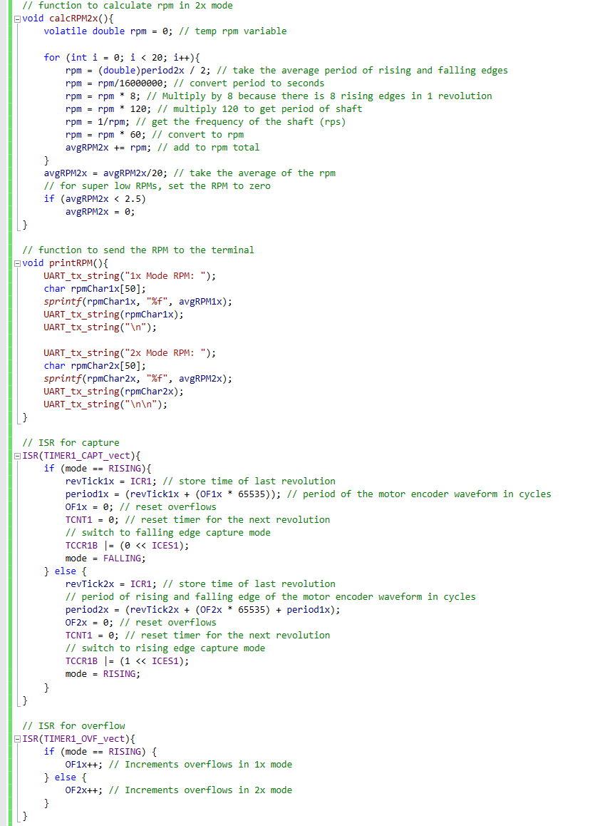

1. **DEVELOPED MODIFIED CODE OF TASK 4 from TASK 3**

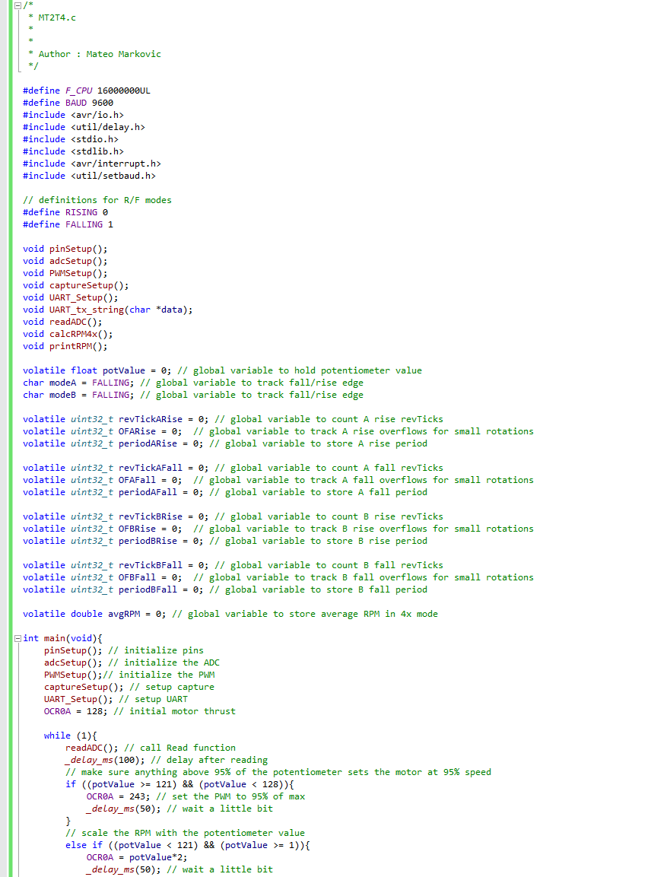

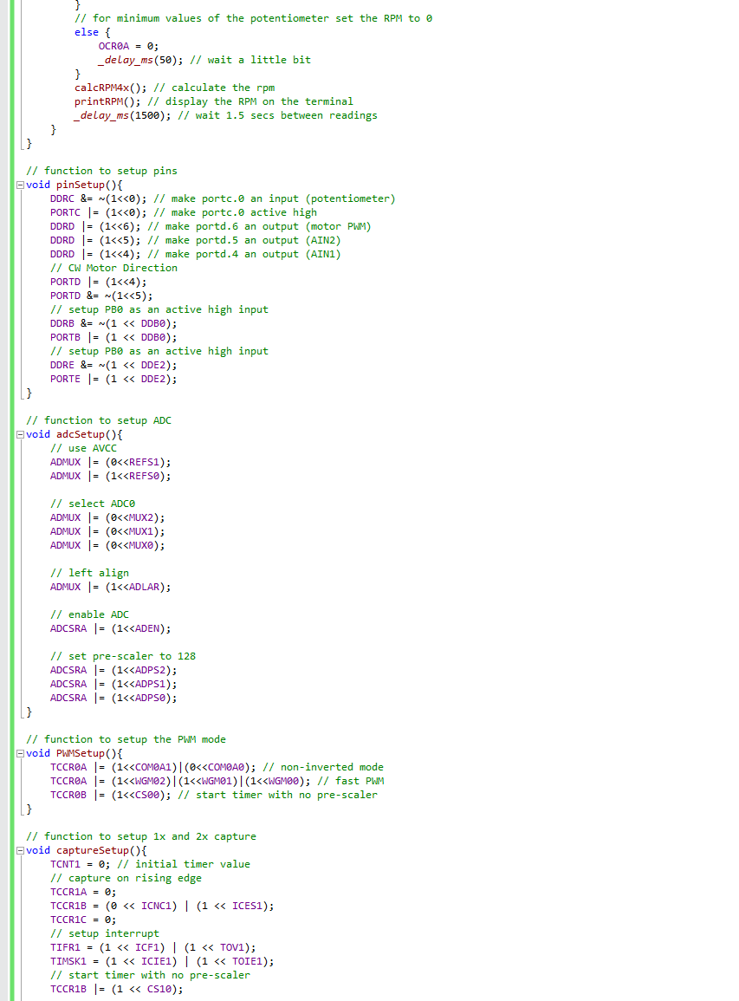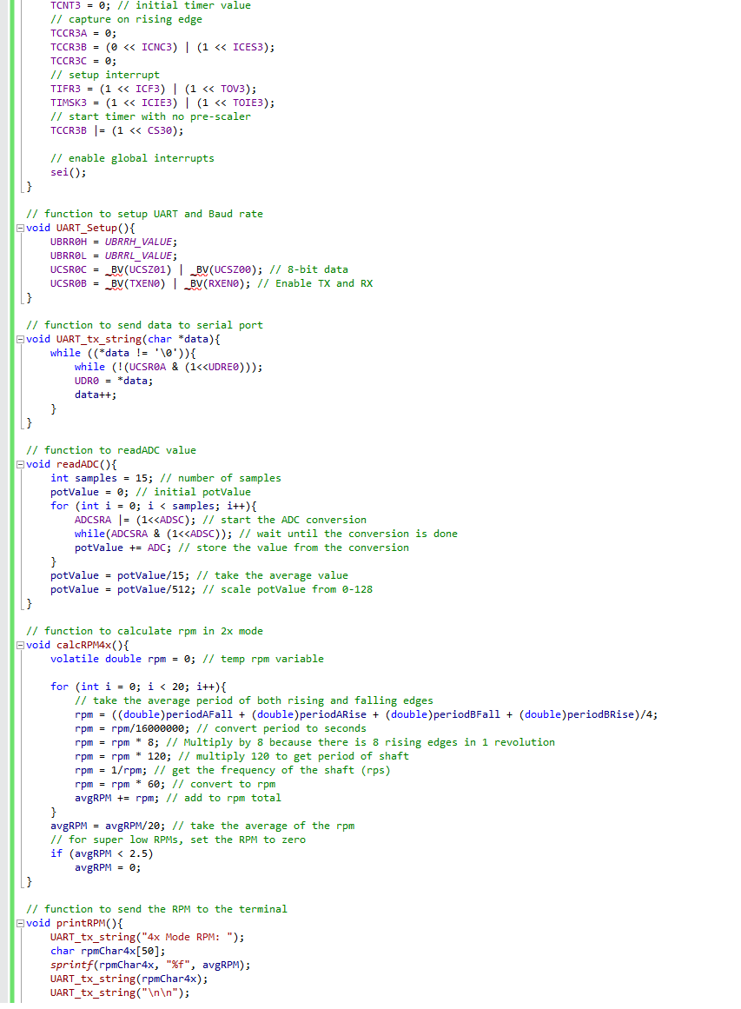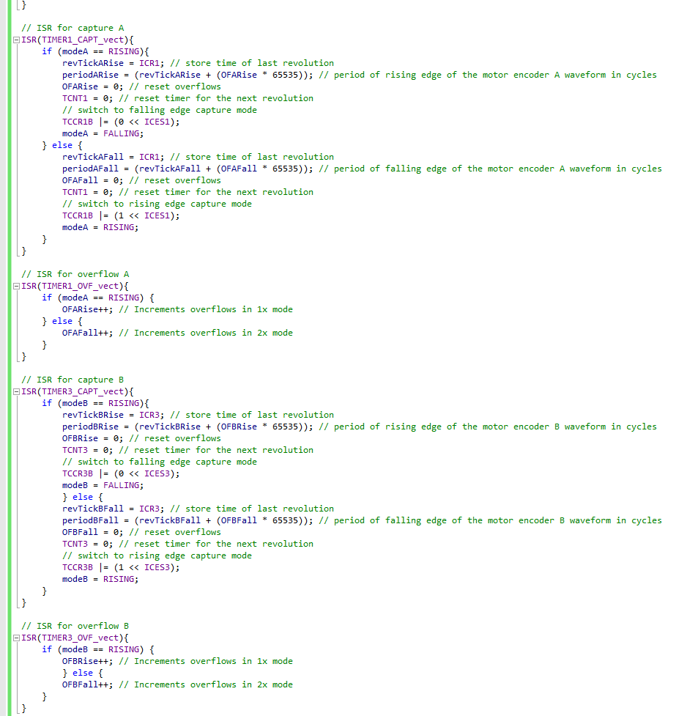

1. **SCHEMATICS**

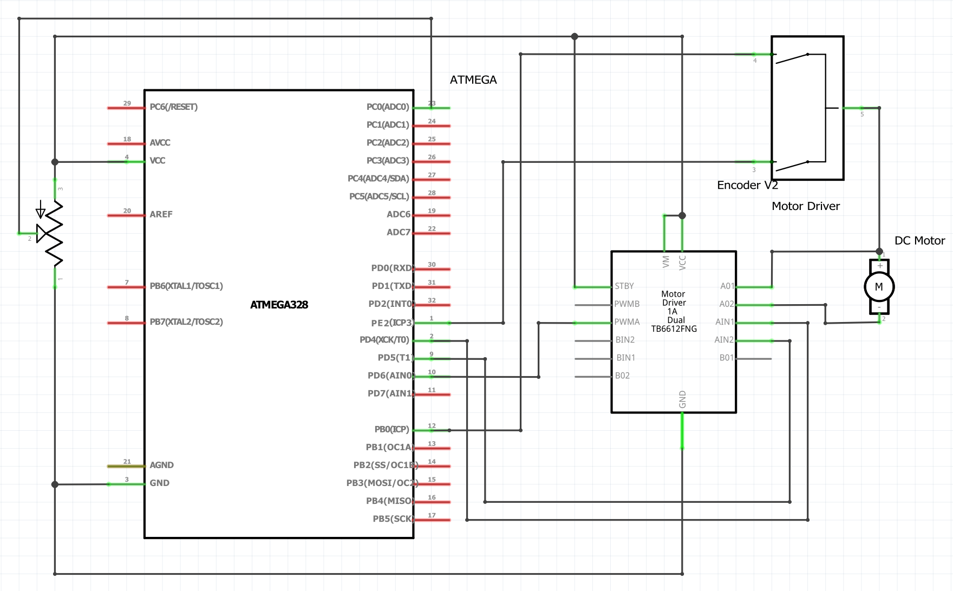

Fritzing Schematic of pins used

1. **SCREENSHOTS OF EACH TASK OUTPUT (ATMEL STUDIO OUTPUT)**

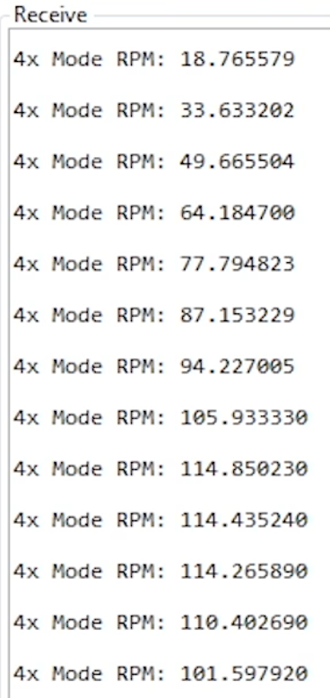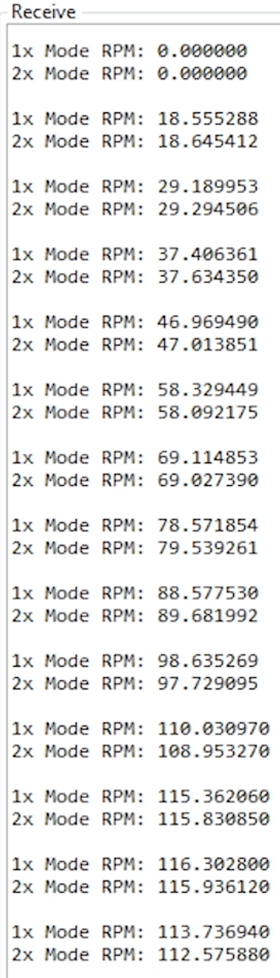

Task 4 Atmel Output

Task 3 Atmel Output

1. **SCREENSHOT OF EACH DEMO (BOARD SETUP)**

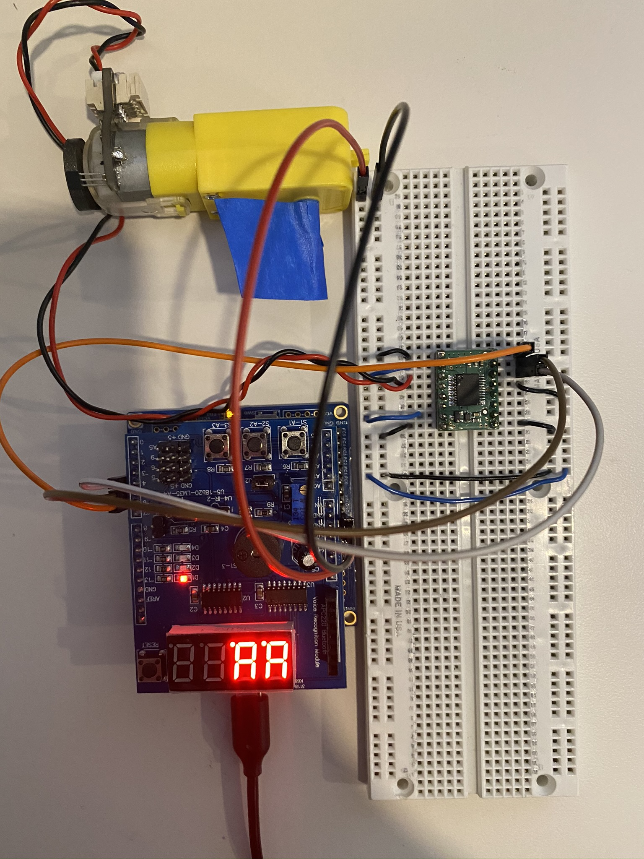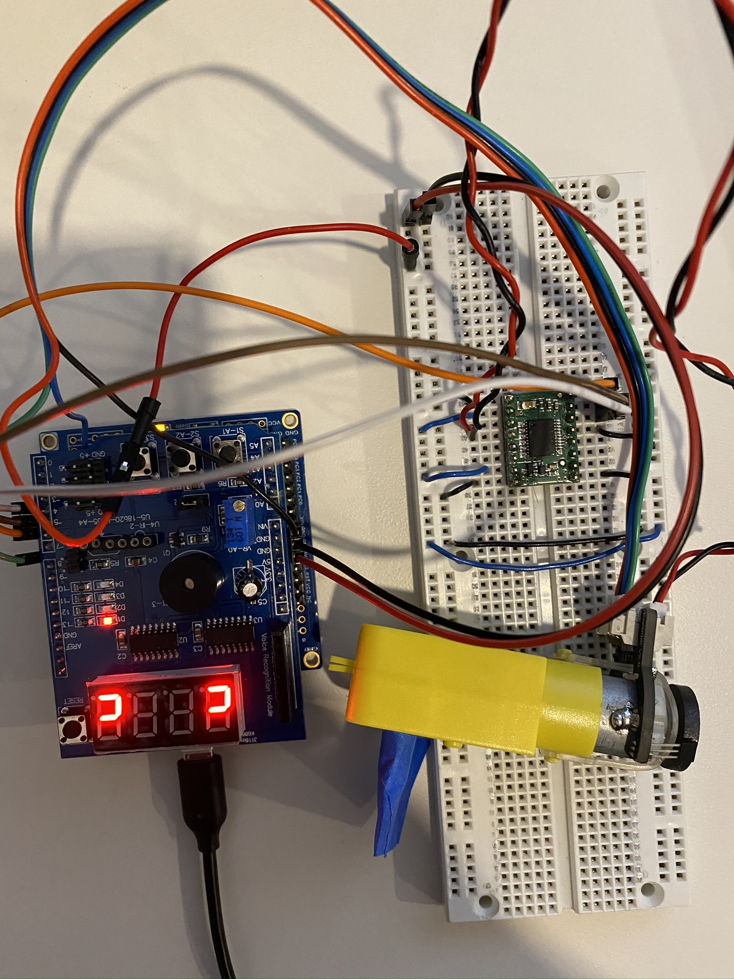

Task 2-4 Board Setup

Task 1 Board Setup

1. **VIDEO LINKS OF EACH DEMO**

Task 1 Demonstration: <https://youtu.be/KosGdSKV_zE>

Task 2 Demonstration: <https://youtu.be/M4LgAuRWjMQ>

Task 3 Demonstration: <https://youtu.be/wPYFQ-AxNAA>

Task 4 Demonstration: <https://youtu.be/5xwrRhdW-9Y>

1. **GITHUB LINK OF THIS DA**

<https://github.com/mateom99/submission_da/tree/master/Midterms/Midterm2>

**Student Academic Misconduct Policy**

<http://studentconduct.unlv.edu/misconduct/policy.html>

“This assignment submission is my own, original work”.

Mateo Markovic